Industrial Sector in a Stochastic Energy Model
Olga V. Livingston, Joseph M. Roop and Brian K. Boyd,
Pacific Northwest National Laboratory

A new energy model is being developed by the Department of Energy’s (DOE) Energy Efficiency and Renewable Energy Office. This model is designed to account for the stochastic nature of both energy research and development (R&D) and the penetration of new technologies, some of which are developed by DOE. Stochastic energy deployment system (SEDS) is a model that fully characterizes the energy economy, including various demand sectors and the electricity, liquid fuels, natural gas, coal and renewable energy sectors. Pacific Northwest National Laboratory developed the industrial module of SEDS. The industrial sector was constructed from an aggregate model of US manufacturing that was developed as part of the Canadian Integrated Modeling System CIMS-US framework.
SEDS is being developed by a consortium of national laboratories, including Argonne National Laboratory (ANL), Oak Ridge National Laboratory (ORNL), the National Renewable Energy Laboratory (NREL), Pacific Northwest National Laboratory (PNNL), Lawrence Berkeley National Laboratory (LBNL), and the National Energy Technology Laboratory (NETL). While it is not meant to be a competitor of the national energy modeling system (NEMS), it does do what NEMS cannot do – look at the probability distributions around key parameters and variables, such as the world price of oil or effects of research and development (R&D) on energy intensity.

Module Structure

This module is primarily an aggregate representation of the US manufacturing sector, which could be enhanced with detailed submodules for a set of specific industries. The model is a typical engineering-economic model of the industrial sector with output, energy use and technology stocks calibrated to the 2006 Manufacturing Energy Consumption Survey (MECS) data, then simulated and benchmarked to the 2010 Annual Energy Outlook (AEO). The industrial sector is linked to the rest of the model through a set of inputs that include fuel prices (natural gas, coal, electricity, oil, light fuel oil and heavy fuel oil), the manufacturing growth rate, the discount rate for levelized cost, emissions tax/cap settings and the carbon content of various fuels. The outputs calculated by the module are energy requirements by fuel type, byproduct gas price, emissions, capital and energy expenditures, as well as the overall sector energy intensity metric. This section contains a brief overview of the module structure, while more detailed explanation with more extensive simulation results can be found in Livingston, Roop and Boyd (2010).
The industrial sector energy consumption is tied explicitly to output produced and the technologies used to produce that output. The module structure is illustrated in Figure 1. The industrial sector module is initialized based on the manufacturing output, which is attributed proportionally to the four major end uses: process heating, process refrigeration, electrochemical processes and other processes. These primary processes have two sets of requirements: a) direct fuel and b) auxiliary services. The latter group requires shaft drive provided by motors of different size classes and efficiencies. Auxiliary requirement coefficients and technological splits for size classes are derived from the CIMS-US model.

Figure 1. Industrial module structure
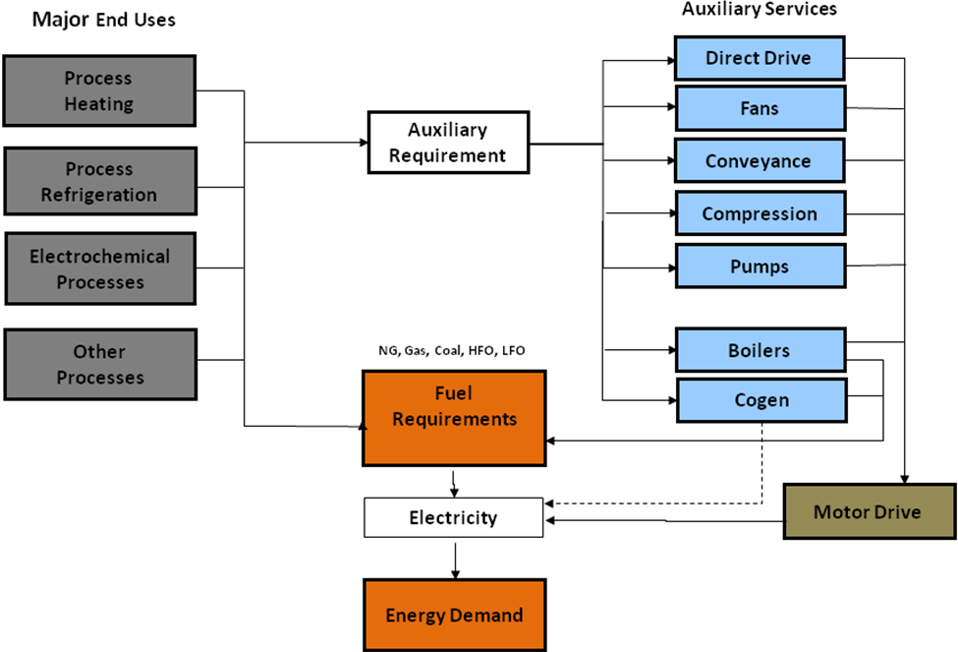

Primary processes reflected in the model are gross representations of averages of equipment contained in the CIMS data base, but themselves have no real-world technology equivalent. While the major end-use modules are not strictly technologies, the auxiliary services that are required by these major end-use modules are defined technologies such as pumps, fans, compressors, conveyors, motors, lighting, boilers and cogeneration.
After direct and indirect energy use is accounted for, the subtotal demand for electricity is lowered by the cogeneration amount. Thus, the total energy demand represents the net quantity of the purchased energy rather than overall energy consumed by the industrial sector. This leads to a CO₂ emissions calculation that is determined by the carbon content of each fuel and the amount of fuel combusted. As mentioned before, energy demand for the initialization year is calibrated to 2006 MECS manufacturing and non-fuel (feedstock) use for the total energy, as well as for each individual fuel type, and then simulated and benchmarked to the AEO 2010 reference case. The difference between MECS data and AEO totals was included in the module as non-manufacturing fuel use.
The main driver for the module is manufacturing output growth. Industrial equipment stock meeting each of the end uses is tracked in the output equivalent. After initial output is proportionately assigned to the major end-use submodules, the model simulates from the base year onward by forecasting the output quantity based on the manufacturing growth rate. Industrial stock flow logic is depicted in Figure 2.
The module tracks several vintages of stock for each technology type, so that each vintage retires subject to its expected economic life. To meet the output projection, the model adjusts the current stock for equipment retirements and then calculates necessary new capacity additions.

Figure 2. Industrial sector stock flow

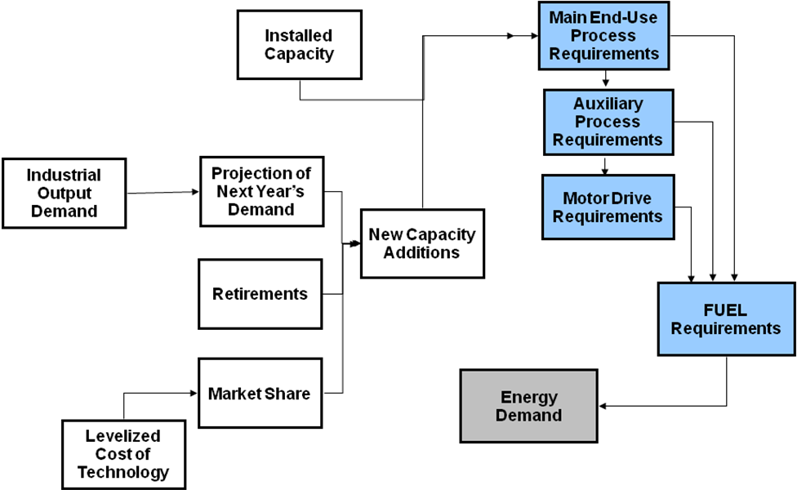

New equipment stock is purchased using a market share calculation that compares different efficiencies of stock and levelized cost. Capital costs, fixed and variable operation and maintenance (O&M) costs, emissions costs, tax incentives, and the expected utilization rates are used to calculate the levelized annual total cost for each technology. Fuel costs, which depend on the rate at which the fuel is used and the price of fuels, are included as well. Capital costs can be decreased as a result of R&D effects and “learning by doing” modeled with a learning curve. The effects of R&D are treated with uncertainty and can be adjusted to try to capture the level of government investment in R&D. Improvements from learning-by-doing are based on cumulative installed capacity, such that a specified percent improvement in capital costs is achieved for each doubling of capacity. Production tax credits, investment tax credits, and accelerated depreciation can be applied to appropriate technologies and will lead to lower levelized annual costs. The combination of all these factors produces a levelized annual cost that is used to determine how the market share of new capacity additions will be given to the competing technologies.
The logit algorithm is used to allocate market shares among competing technologies, and it reflects a probabilistic cost minimization process, with overlapping distributions of technology costs determining the point at which costs are minimized. Given a total demand, a list of technologies that could meet that demand (each with specified utility and capacity), the market share competition algorithm uses a logit choice function to generate the total quantity of new added capacity for each technology. In this version of the industrial sector, new added capacity for each technology is calculated based on the technologies’ “utility”, which is defined as levelized costs. When available, information from case studies may sometimes inform parameter selection for the logit function; otherwise, we use a parameter value that follows the rule-of-thumb that a 15% cost differential captures 80% of the new market share. If the high utility technologies cannot meet the desired demand as determined by the market share calculated above, the excess demand is allocated to the other suppliers in proportion to each technology's utility, and iterations occur until demand is met. If the proportionately scaled-up capacity mix is not sufficient to meet projected demand, then the entire capacity from every technology supplier is purchased regardless of the optimal share mix. Finally, these new capacity allocations are added to the existing stock of equipment minus that time period's retirements. The resulting stock then matches demand. Once the stock of equipment has been changed to reflect additions and retirements, fuel use is calculated.
There are three generations of technologies that compete for new stock additions: current, state-of-the-art and advanced. Current generation captures the technologies that are available now and will not be competing for new share additions after 2015. This generation has lower levelized capital cost, but high fuel intensities. The state-of-the-art (SOA) is competitive with the current stock immediately; the advanced technology becomes competitive with these two in 2025. The SOA and advanced technologies have higher capital cost and a lower fuel requirement.
Multiple fuel options, such as natural gas, electricity, coal, light and heavy fuel oil (LFO and HFO) and byproduct gas, are included for each of the technology types where fuel substitution is appropriate. This module is structured such that process heating uses electricity, coal, natural gas and byproduct gas. Only a very minor portion is serviced by LFO. Process refrigeration and cooling uses either electricity or natural gas absorption cooling. The electro-chemical processes are dominated by electricity use. Other processes, a general category that accounts for primary processes not included in the previous three categories, is serviced by coal, natural gas, electricity and byproduct gas, with a small fraction using LFO.
Just like the end-use service equipment, auxiliary services compete on the basis of costs to satisfy requirements needed by the major end-use services for the production of manufacturing goods. Capital costs, operating and maintenance costs, and performance characteristics for all the auxiliary equipment are drawn from the CIMS-US data base, and are currently being updated.
As one would expect for any attempt at modeling a complex system, this module has some limitations and simplifying assumptions, which should be explained to gain a better understanding of model results and prioritize future work. Because it is primarily a representation of the US manufacturing sector, the module is national in scope and lacks both regional and industry detail. Although no industry-specific technologies appear in the module, it does cover many of what the Industrial Technologies Program (ITP) calls cross-cutting technologies: compression, air displacement, conveyance, boilers, pumping and motor drive. In place of these industry-specific technologies, there are fuel-specific “quasi-technologies” for process heating, process cooling, electro-chemical processing, and other processes.
The use of “quasi-technologies” is one of the limiting factors of the model in part because, unlike industry-specific technologies, it is more difficult to handle fuel switching and market share competition. In addition, the technical performance of these quasi-technologies is somewhat inconsistent with industry-specific performance (e.g. the aggregate SOA technologies that replace current average performance technologies may not be nearly as efficient as industry-specific SOA technologies).

Bibliography

Analytica Professional 4.2 by Lumina Decisions Systems, Inc. February 2010.
Bataille, Christ G.F.(2005) Design and Application of a Technologically Explicit Hybrid Energy-Economy Policy Model with Micro and Macroeconomics Dynamics; School of Resources and Environmental Management, Simon Fraser University PhD thesis.
Browne, Marilyn A. et al (1998). Engineering-Economic Studies of Energy Technologies to Reduce Greenhouse Gas Emissions: Opportunities and Challenges; Annual Review of Energy and Environment, 23: 287-385
Canadian Integrated Modeling System (CIMS), 2008. Energy and Materials Research Group, Simon Fraser University, British Columbia, Canada.
Cohendet, P. 1997. Evaluating the Industrial Indirect Effects of Technology Programmes: the Case of the European Space Agency (ESA) Programmes. Proceedings of the OECD Conference “Policy Evaluation in Innovation and Technology”, B.E.T.A, Université Louis Pasteur, Strasbourg, France. Available on-line http://www.oecd.org/dataoecd/3/37/1822844.pdf
Jaccard, M. and J. Nyboer. 1992. ISTUM-PC User Guide, Vol 1, Model Description. Simon Fraser University, Vancouver, Canada
Livingston, Olga V., J.M. Roop and B. K. Boyd. 2010. Impact of Carbon Policy on Industry Use of Coal, Natural Gas and Electricity in a Stochastic Energy Model. 29th USAEE/IAEE North America conference, October 2010, 29th USAEE/IAEE conference proceedings, Calgary,Alberta, Canada.
McFarland, J.R., J.M. Reilly and H.J.Herzog (2004). Representing energy technologies in top-down economic models using bottom-up information; Energy Economics, 26: 685-707
Rivers, Nic, and Mark Jaccard (2005). Combining Top-Down and Bottom-Up Approaches to Energy-Economy Modeling Using Discrete Choice Models; the Energy Journal, 26(1): 83 – 106
Roop, Joseph M. and O. Livingston. 2009. SEDS Industry Module. Pacific Northwest National Laboratory, Richland, Washington. Working notes, June 2009.
Train, Kenneth E. (2003). Discrete Choice Methods with Simulation; Cambridge University Press, Cambridge
U.S. Energy Information Administration, Annual Energy Outlook, Reference Case 2010. May 11, 2010. Washington, D.C.
U.S. Energy Information Administration, Manufacturing Energy Consumption Survey, 2006, Table 10.10, Release of June 2009, Washington, D.C.
U.S. Energy Information Administration, National Energy Modeling System. May 2010. Washington, D.C.
Worrel, Ernst, Stephan Ramesohl and Gale Boyd (2004). Advances in Energy Forecasting Models Based on Engineering Economics; Annual Review of Environment and Resources, 29: 345-381

{JAMES MILFORD model reference for the NREL-developed demand template}.

